**PRACTICAL – 1**

**Q1) Write a program to enter two integers, two floating numbers and then perform all arithmetic operations on them.**

**Code:**

**int1 = int(input("Enter integer 1: "))**

**int2 = int(input("Enter integer 1: "))**

**float1 = float(input("Enter float 1: "))**

**float2 = float(input("Enter float 2: "))**

**print("\n*******ARITHMETIC OPERATIONS ON INTEGERS*******")**

**print("ADDITION: ",int1,' + ',int2,' = ',int1+int2)**

**print("SUBTRACTION: ",int1,' - ',int2,' = ',int1-int2)**

**print("MULTIPLICATION: ",int1,' * ',int2,' = ',int1*int2)**

**print("DIVISION: ",int1,' / ',int2,' = ',int1/int2)**

**print("FLOOR DIVISION: ",int1,' // ',int2,' = ',int1//int2)**

**print("EXPONENTIATION: ",int1,' ^ ',int2,' = ',int1**int2)**

**print("\n*******ARITHMETIC OPERATIONS ON FLOATING POINT*******")**

**print("ADDITION: ",float1,' + ',float2,' = ',float1+float2)**

**print("SUBTRACTION: ",float1,' - ',float2,' = ',float1-float2)**

**print("MULTIPLICATION: ",float1,' * ',float2,' = ',float1*float2)**

**print("DIVISION: ",float1,' / ',float2,' = ',float1/float2)**

**print("FLOOR DIVISION: ",float1,' // ',float2,' = ',float1//float2)**

**print("EXPONENTIATION: ",float1,' ^ ',float2,' = ',float1**float2)**

**Output:**

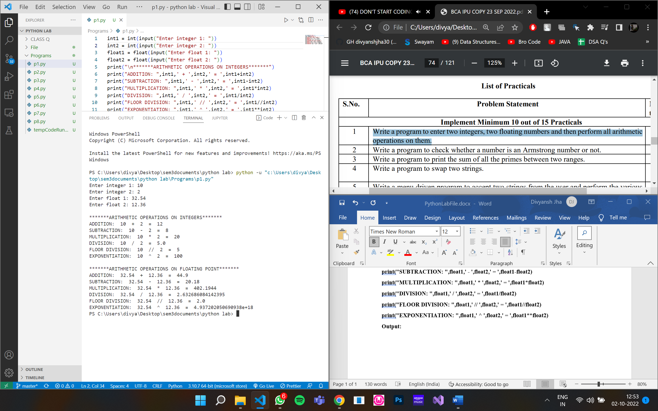

**PRACTICAL – 2**

**Q2) Write a program to check whether a number is an Armstrong number or not.**

**Code:**

**num = int(input("Enter a number: "))**

**summ = 0**

**n1 = num**

**while num != 0:**

**rem = num%10**

**summ = summ + rem ** 3**

**num = num//10**

**if(n1 == summ):**

**print(n1,"is an Armstrong number.")**

**else:**

**print(n1,"is not an Armstrong number.")**

**Output:**

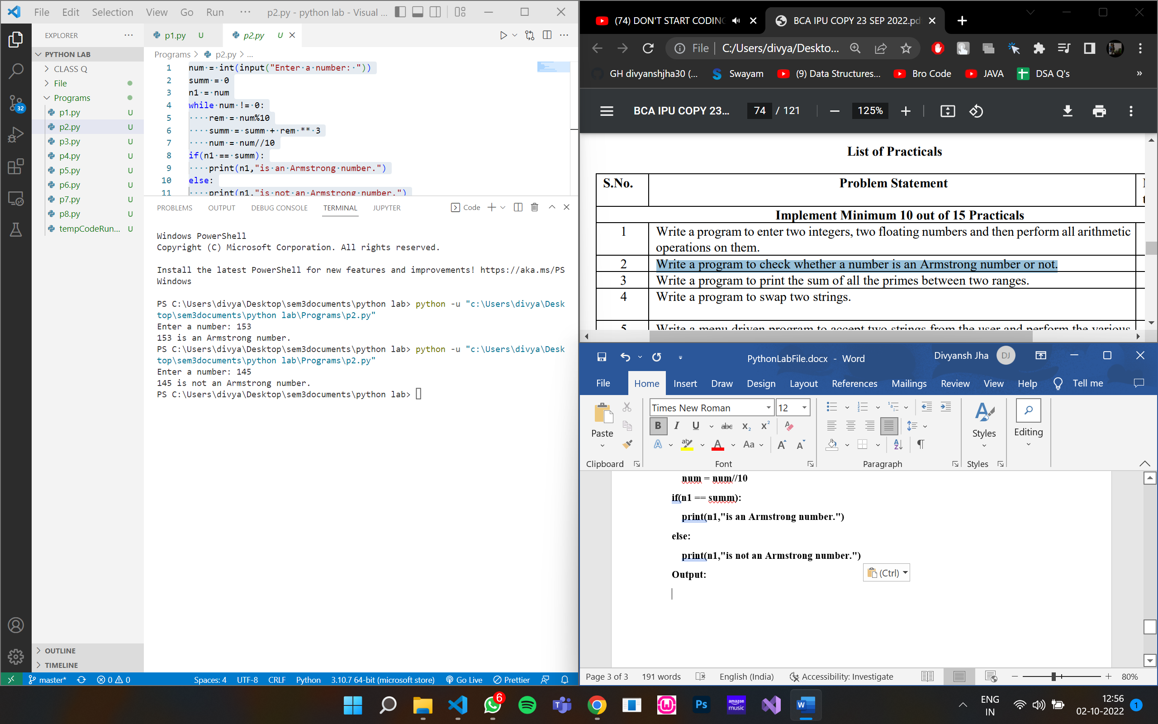



**PRACTICAL – 3**

**Q3) Write a program to print the sum of all the primes between two ranges.**

**Code:**

**lr = int(input("Enter the lower range: "))**

**ur = int(input("Enter the upper range: "))**

**s = 0**

**flag = 0**

**for i in range (lr,ur+1):**

**flag = 0**

**if(i>1):**

**for j in range (2,i):**

**if(i%j==0):**

**flag += 1**

**if(flag == 0):**

**print(i)**

**s += i**

**print("Sum =",s)**

**Output:**

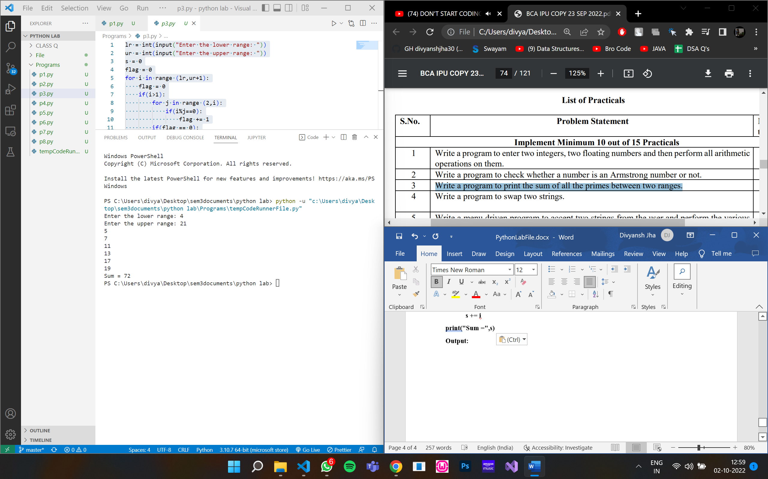

**PRACTICAL – 4**

**Q4) Write a program to swap two strings.**

**Code:**

**str1 = input("Enter your first string: ")**

**str2 = input("Enter your second string: ")**

**print("String 1 before swapping: ",str1)**

**print("String 2 before swapping: ",str2)**

**str1 = str1+str2**

**str2 = str1[0 : (len(str1) - len(str2))]**

**str1 = str1[len(str2) : ]**

**print("String 1 after swapping: ",str1)**

**print("String 2 after swapping: ",str2)**

**Output:**

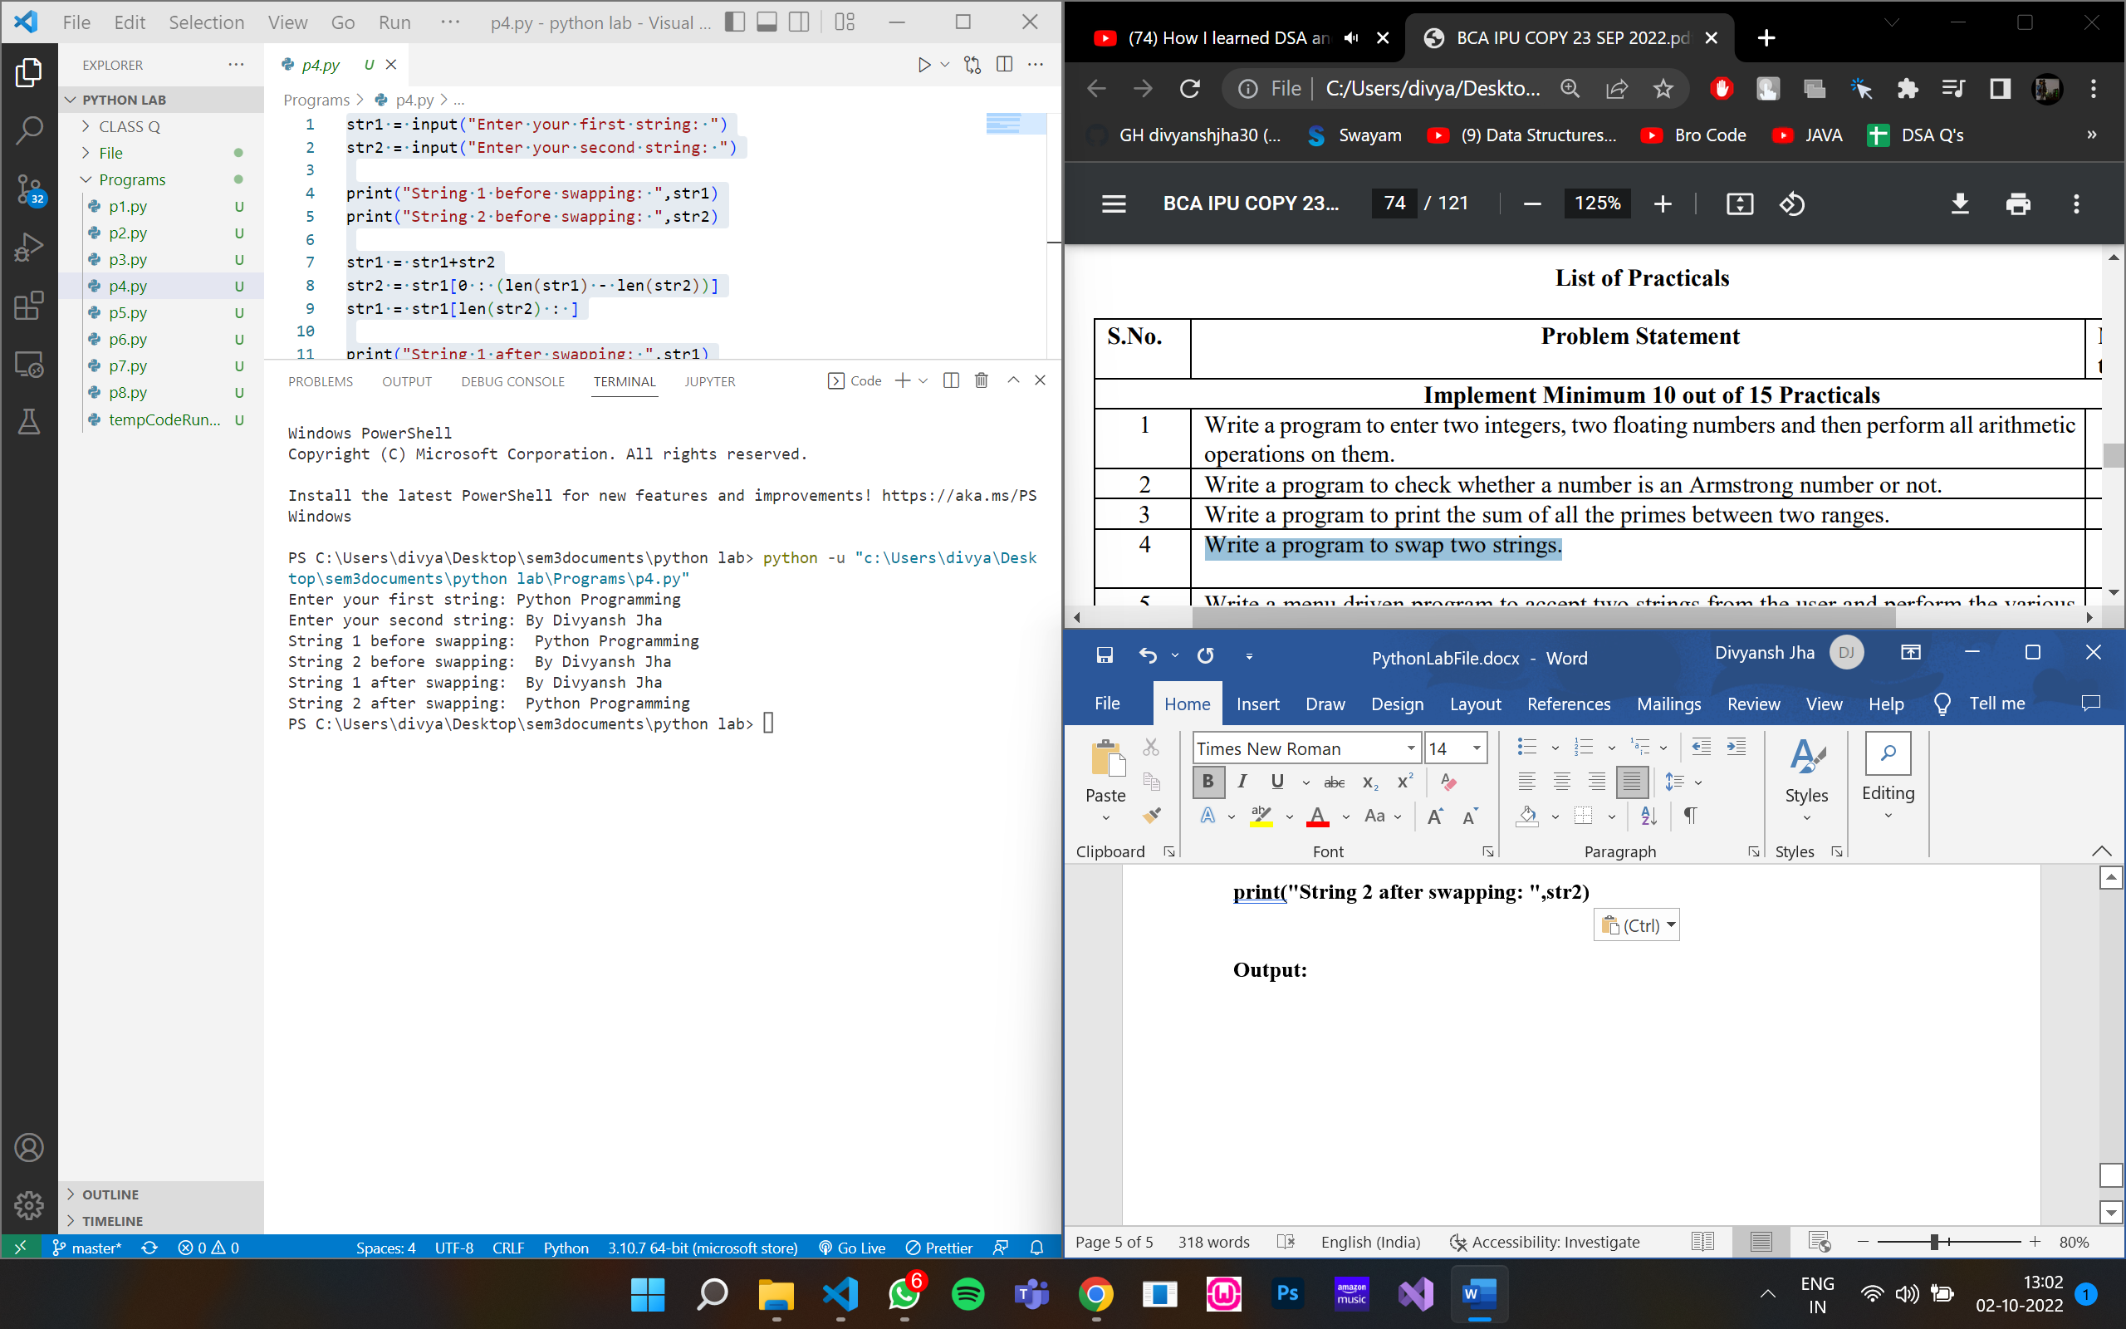

**PRACTICAL – 5**

**Q5) Write a menu driven program to accept two strings from the user and perform the various functions using user defined functions.**

**Code:**

**Output:**

**PRACTICAL – 6**

**Q6) Write a program to find smallest and largest number in a list.**

**Code:**

**lst = []**

**num = int(input('How many numbers: '))**

**for n in range(num):**

**numbers = int(input('Enter number: '))**

**lst.append(numbers)**

**print("Largest number in the list is :", max(lst), "\nSmallest number in the list is :", min(lst))**

**Output:**

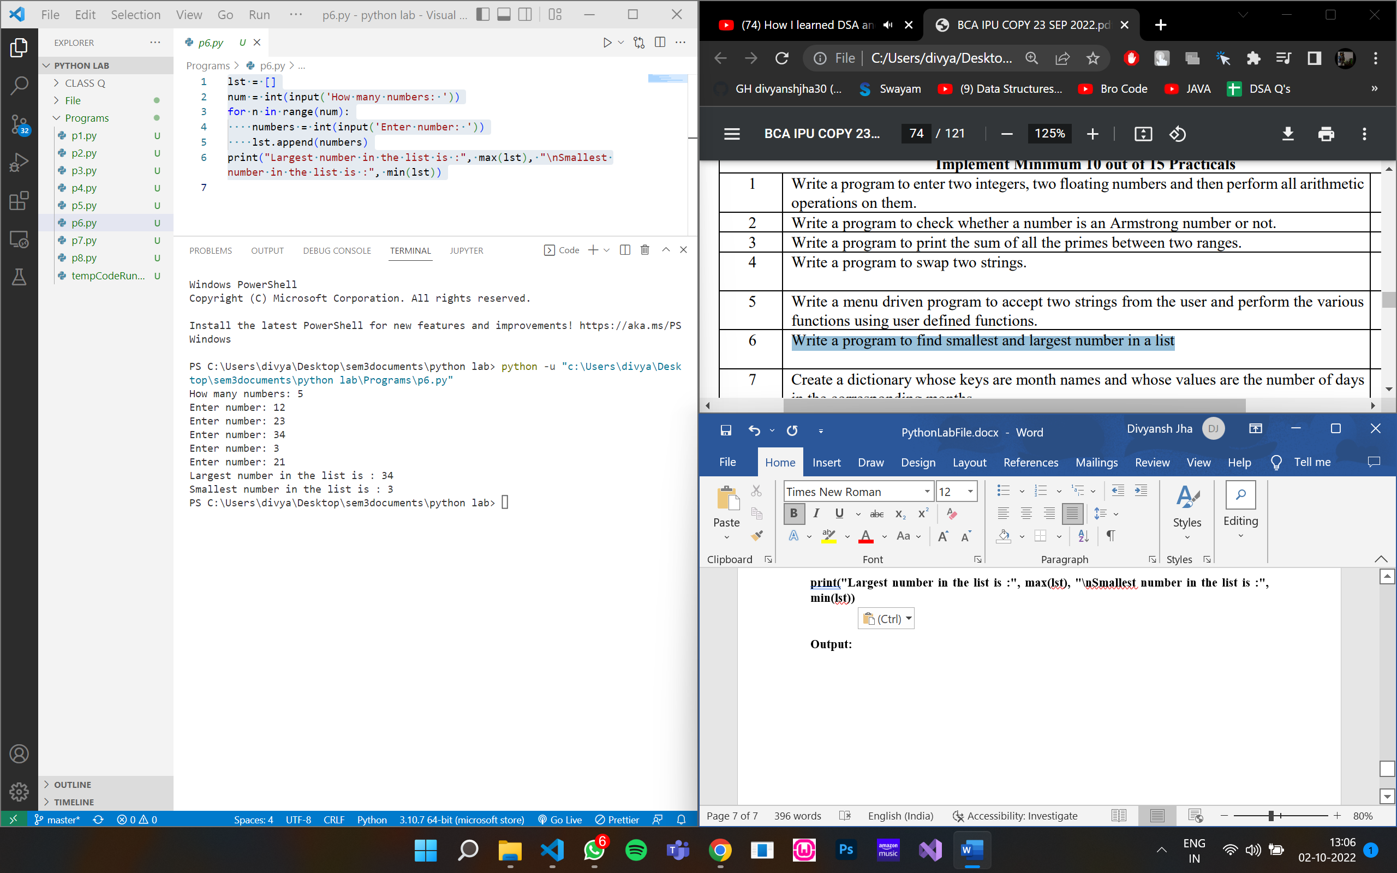

**PRACTICAL – 7**

**Q7) Create a dictionary whose keys are month names and whose values are the number of days in the corresponding months.**

* **Ask the user to enter a month name and use the dictionary to tell them how many days are in the month.**
* **Print out all keys in the alphabetically order**
* **Print out all the months with 31 days**
* **Print out the key value pairs sorted by number of days in each month**

**Code:**

**Output:**

**PRACTICAL – 8**

**Q8) Make a list of first 10 letters of the alphabet, then use the slicing to do the following operations:**

* **Print the first 3 letters of the list**
* **Print any 3 letters from the middle**
* **Print the letter from any particular index to the end of the list**

**Code:**

**lst = ['a','b','c','d','e','f','g','h','i','j']**

**print("The list containing first 10 letters of the alphabet: ",lst)**

**print("First three letters of the alphabet: ",lst[0:3])**

**print("Three letters from the middle are: ",lst[4:7])**

**print("All letters from a particular index = (5): ",lst[5:])**

**Output:**

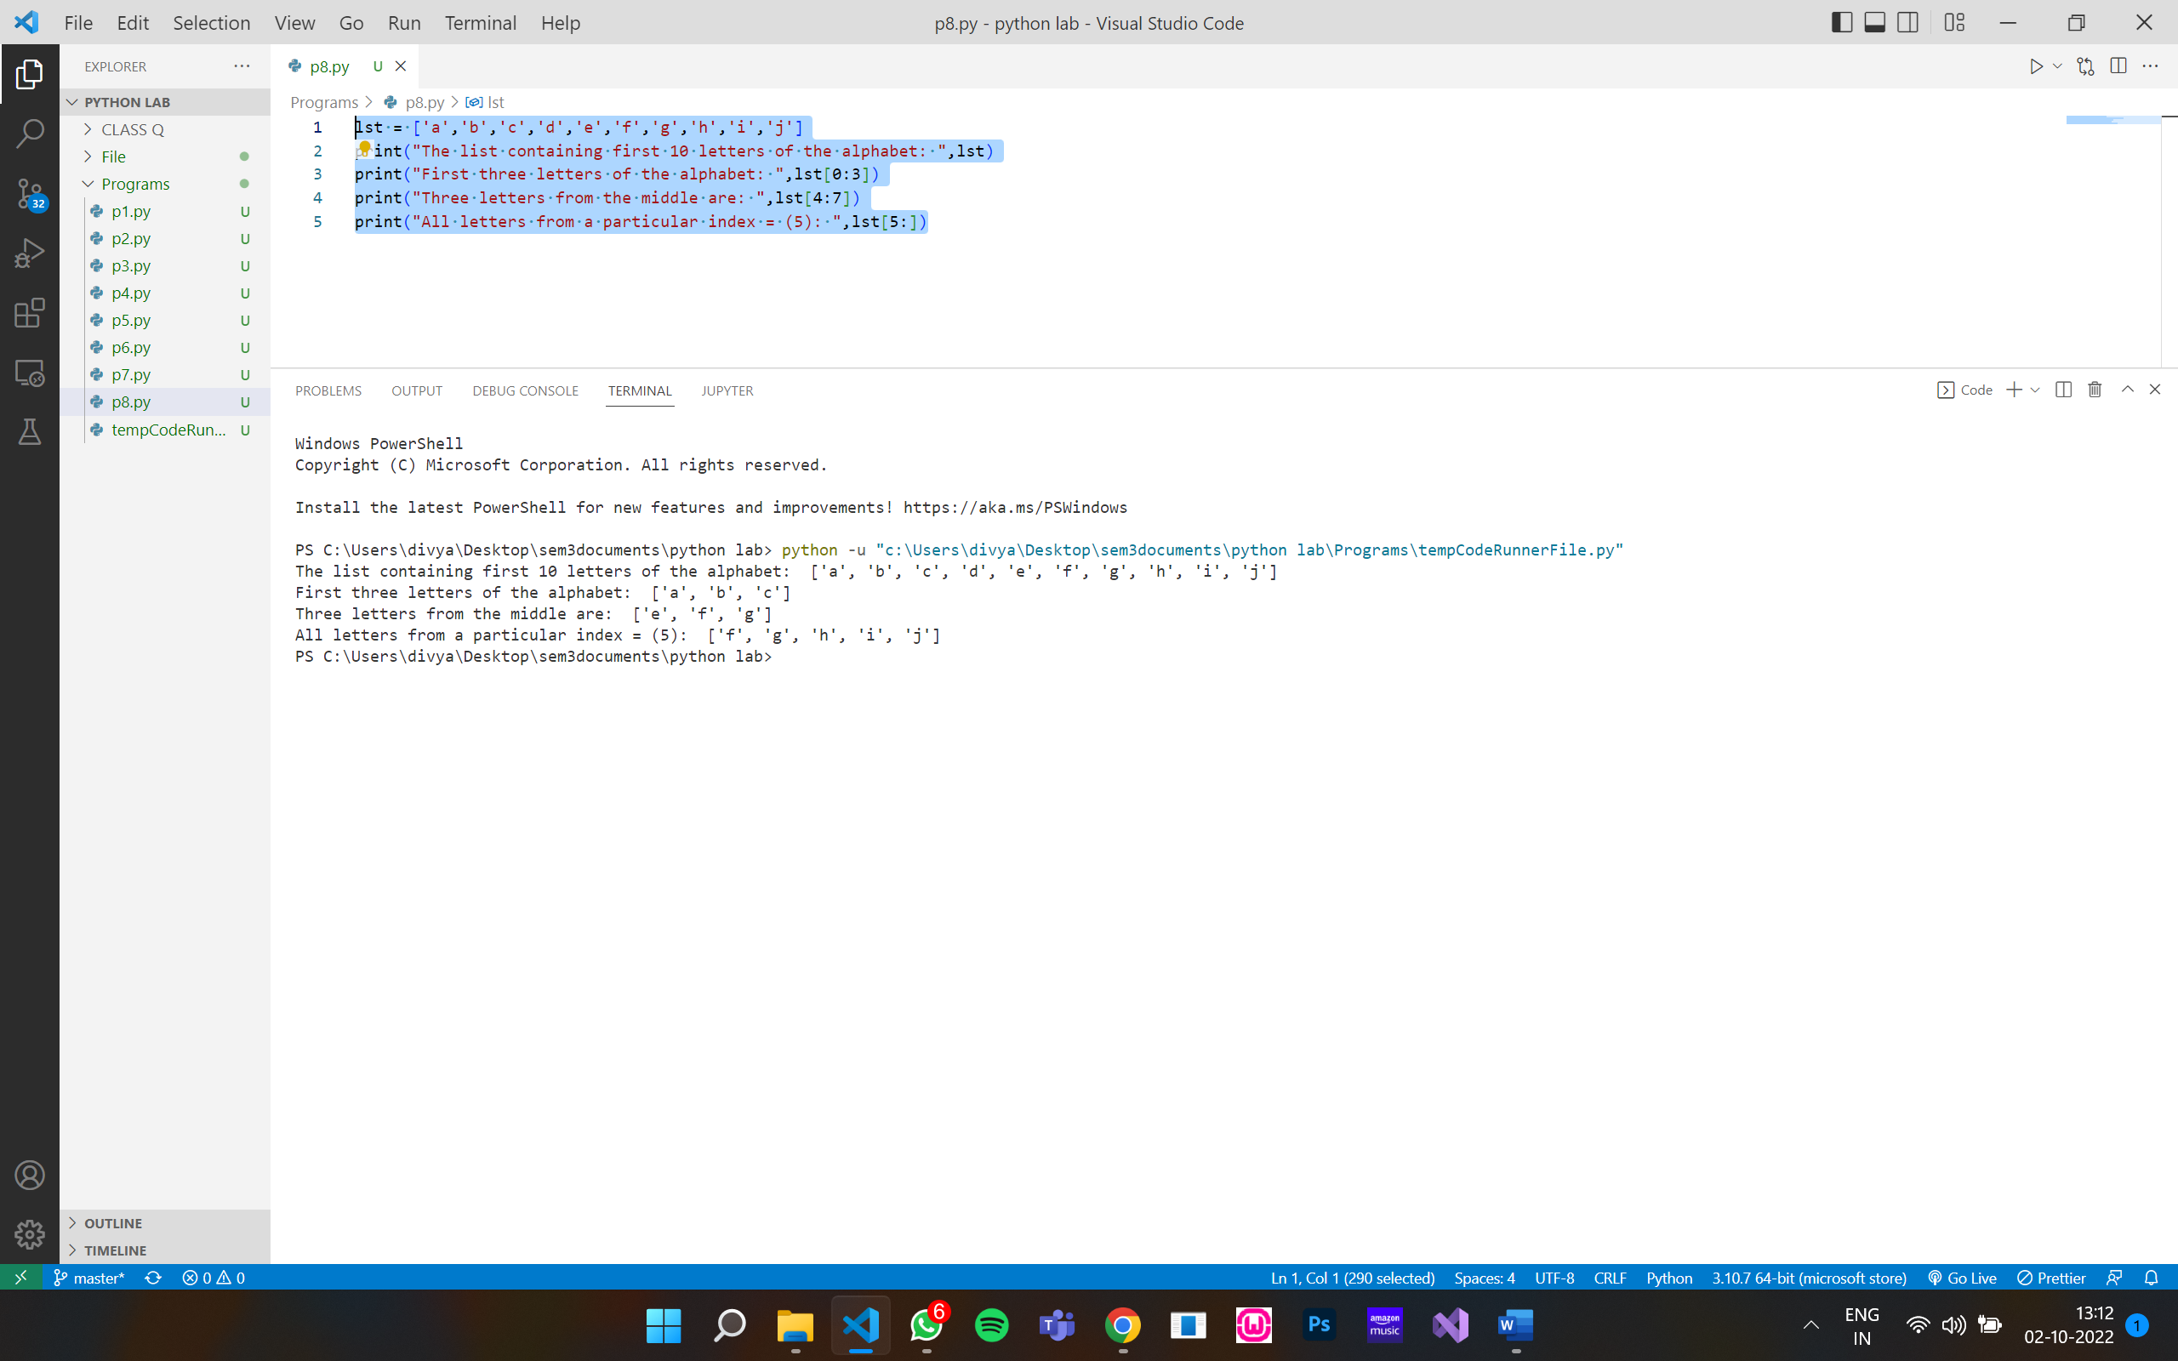

**PRACTICAL – 9**

**Q9) Write a program that scans an email address and forms a tuple of user name and domain.**

**Code:**

**Output:**